

ALLERGY, ASTHMA & EPILEPSY SAFETY POLICY 2026-2027

Table of Contents | Page number
Allergy, Asthma & Epilepsy Principles | 2
Roles & Responsibilities | 3
Individual Health Care Plans (IHP) | 5
Register of students with known allergies | 7
Minimising risk | 8
Procedures for handling an allergy reaction | 10
Summary of anaphylaxis signs | 12
Emergency Procedures flowchart | 13
Recording incidents | 14
Supporting students with epilepsy | 15
Supporting students with asthma | 21
Supporting students with diabetes | 24

Approved by: The Governing Board
Last review: September 2026 | Next review: September 2027

Allergy, Asthma & Epilepsy policy principles
Dorset Studio School is committed to ensuring that students with medical conditions are properly supported so that they have full access to education, including school trips, practical activities, enrichment opportunities and physical education.
The school endeavours to ensure that all students can enjoy and thrive in the land-based specialism we deliver.
No student with a medical condition will be denied admission or prevented from taking part in school activities because arrangements for their medical condition have not been made.
The school aims to:
- Support students with both short-term and long-term medical conditions.
- Ensure students can access and enjoy the same opportunities as their peers.
- Reduce barriers to attendance, participation, and achievement.
- Keep students safe through effective risk assessment, planning, and staff training.
- Work closely with parent(s), carer(s), families, health professionals and external agencies.

Legal and Statutory Framework

The school has the best intentions to meet all statutory duties relating to medical conditions and allergy management.

This policy also reflects statutory policy and recent statutory developments regarding allergy safety in schools.
- Allergy Safety in Schools 2026
- Children and Families Act 2014
- DfE Supporting Pupils at School with Medical Conditions Guidance
- DfE Allergy Safety Guidance
- Equality Act 2010
- SEND Code of Practice (2015)
- Health and Safety at Work Act 1974
- Human Medicines Regulations 2012
- Relevant NHS and NICE clinical guidance
- Supporting students with medical conditions in schools
- The Food Information Regulations 2014
- The Food Information (Amendment) (England) Regulations 2019
- using emergency adrenaline auto-injectors in schools,
Diabetes, severe allergies, asthma and some chronic illnesses, may also constitute disabilities under the Equality Act 2010.
Reasonable adjustments will therefore be made where required.
Links with other policies:
- The Anti-Bullying Policy 2026-2027
- The Behaviour & Rewards Policy 2026-2027
- The DSS Accessibility Plan
- The DSS Special Educational Needs & Disabilities Policy 2026-2027
- The Special Educational Needs Information Report 2026-2027
- The Teaching & Learning Policy 2026-2027
- DSS Accessibility Plan
Roles and Responsibilities

The Governing Body
The Governing Body will:
- Ensure arrangements are in place to support pupils with medical conditions.
- Ensure sufficient staff receive appropriate training.
- Monitor effectiveness of the policy.
- Ensure adequate insurance arrangements are maintained.
Allergy Safety Lead
The allergy safety lead is Maddy Irvine.
They are responsible for:
Reviewing the allergy safety policy at least annually, updating it when needed, and making sure it is published
Promoting and coordinating allergy awareness across our school community alongside members of the wider pastoral and administrative teams
Reviewing arrangements for the safe storage and disposal of adrenaline devices

They ensure:

- All allergy information is up to date and readily available to relevant members of staff
- All students who require support with allergies have an up-do-date Individual Healthcare Plan (IHP)
- All students with a known food or insect sting allergy have up-to-date allergy action plans issued by a medical professional
- All staff receive regular allergy awareness training
- All staff are aware of the school’s policy and procedures regarding allergies
- Relevant staff are aware of what activities need an allergy risk assessment
- Serious incidents and ‘near misses’ relating to allergy safety are recorded and reported as appropriate, and to consider and share with staff:
- What lessons there are to learn
- Any potential changes to the medical conditions and/or allergy safety policies and/or to any pupil’s IHP

- Tracey Richards is responsible for developing the correct procedure to store all medications and how the medication is accessed and accounted for.
- Tracey Richards is also responsible for ensuring that there are sufficient emergency auto-injectors available in school on both sites.

- Nadine Hill (Kingston Maurward) and Julia Burgess (Poundbury) are responsible for:

- Checking spare AAIs are present and in date monthly
- Making sure that replacement AAIs are obtained when expiry dates approach

The Principal
The Principal will:
- Ensure the Implementation of this policy.
- Ensure suitable arrangements are in place.
- Ensure staff are aware of pupils' medical needs.
- Ensure Individual Healthcare Plans (IHPs) are developed where required.

ALL Staff
All Staff will:
- Be aware of students with medical conditions.
- Follow Individual Healthcare Plans.
- Attend training relevant to their role.
- Respond appropriately in emergencies.

Parent(s), Carer(s) and families

Parent(s), Carer(s) and families are responsible for:
- Being aware of our school’s allergy safety policy
- Following the school’s guidance on food brought in to be shared
- Providing accurate medical information.
- Providing the school with up-to-date details of their child’s medical needs, dietary requirements, and any history of allergies, reactions and anaphylaxis
- Informing the school of changes in medical circumstances.
- Providing prescribed medication where required.
- Participating in healthcare plan reviews.

If required, providing their child with TWO in-date adrenaline auto-injectors and any other medication, including inhalers, antihistamine etc., and making sure these are replaced in a timely manner

Students with allergies
Students should:
- Participate in discussions about their healthcare where appropriate.
- Carry medication where agreed within healthcare plans.
- Inform staff immediately if they become unwell.

Students without allergies

These students should be:

- Be aware of allergens and the risk they pose to their peers in their classes
Older students might also be able support their peers and staff in the case of an emergency.

Individual Healthcare Plans (IHPs)
It is not necessary for a student to have a formal diagnosis of an allergy for them to have an IHP. Healthcare professionals may decide that it is more appropriate to accept that the child shows symptoms, rather than proceeding to a formal diagnosis.
The IHP will set out the additional and/or different arrangements that will be in place for supporting the pupil. The school will make every effort to make sure that arrangements are put in place within 2 weeks, or by the beginning of the relevant term for pupils who are new to our school.
Not all students with an allergy will require an IHP. Some allergies will have little or no impact on the pupil while they are at school or pose no risk to the student. Some allergies will not require arrangements which are additional to or different from those made generally.
The Principal has overall responsibility for deciding (in discussion with the parent(s), carer(s) family and any relevant healthcare professionals) whether a pupil’s allergy can be managed through the adjustments made under the school’s medical conditions policy or whether an IHP is required to specify arrangements that reflect the pupil’s circumstances.
The school will consider the following principles:
- If the arrangements or support which a student requires would be available to any student as part of normal policies, an IHP may not be required
- If the student only needs non-prescription medication and the school’s medical conditions policy would permit them to carry and administer it, an IHP may not be required
- If the student is at risk or harm because of an allergy

An IHP will include:
- Medical diagnosis and symptoms.
- Daily management arrangements.
- Medication requirements.
- Emergency procedures.
- Staff responsibilities.
- Educational, attendance and participation considerations.
- Consent arrangements.
- Review dates.
IHPs will normally be reviewed annually or sooner if circumstances change.

Benedict's Law and Allergy Safety
The school acknowledges the significant reforms commonly known as ‘Benedict's Law’, developed following the death of Benedict Blythe from an allergic reaction at school in 2021.
The measures associated with Benedict's Law have strengthened national expectations regarding allergy safety in schools, includinreactions,
- Whole-school approaches to allergy management.
- Published allergy safety policies.
- Improved staff training.
- Access to emergency adrenaline auto-injectors.
- Stronger Individual Healthcare Plan requirements.
- Improved recording, reporting and learning from incidents.
In line with these developments, the school will:
- Maintain a separate Allergy Safety Procedure.
- Provide regular allergy awareness training.
- Undertake risk assessments for trips, catering and practical lessons.
- Ensure all allergy incidents and near misses are recorded and reviewed.

Allergy and asthma action plans
- All students who have a known allergy to a food or insect stings should be issued with an appropriate allergy action plan by their healthcare professional.
- All students who have asthma should be issued with an asthma action plan by their healthcare professional.
The plans include medical and/or parental/carer/family consent for staff to administer emergency medicines, including adrenaline for anaphylaxis or reliever inhaler in the event of an asthma attack.
The allergy action plan and/or asthma action plan should be attached to the pupil’s IHP.
Whenever the allergy action plan is updated, the student’s IHP should be reviewed to incorporate it.
Register of students with known allergies

The school maintai),s a register of pupils who have a known allergy. The register includes:
- Known allergens and risk factors for anaphylaxis
- Whether a student has been prescribed ADs (and if so, what type and dose)
- Where a student has been prescribed an AD, whether parental consent has been given to administer emergency medication
- A photograph of each student to allow a visual check to be made (this will require parental/ carer/family consent)

- The register is kept in reception on each school site. It is clearly labelled and can be checked quickly by any member of staff as part of initiating an emergency response
Students are allowed to keep Adrenaline Devices with them will reduce delays and allows for confirmation of consent without the need to check the register.

Anaphylaxis occurrence
Around 8% of children in the UK have a food allergy. However, most allergic reactions to food are not anaphylaxis, even in children with previous anaphylaxis. Most reactions present with mild-moderate symptoms, and do not progress to anaphylaxis. Fatal allergic reactions are rare, but they are also very unpredictable.
In the UK, 17% of fatal allergic reactions in school-aged children happen while at school.
Anaphylaxis
Anaphylaxis is an allergic reaction occurs because the body’s immune system reacts inappropriately to a substance that it wrongly perceives as a threat. The reaction is due to an interaction between the substance (“allergen”) and an antibody called Immunoglobulin E (IgE). This results in the release of chemicals such as histamine which cause the allergic reaction.
In the skin, this causes an itchy rash, swelling and flushing. Many children (not just those with asthma) can develop breathing problems, like an asthma attack. The throat can tighten, causing swallowing difficulties and a high-pitched sound (stridor) when breathing in. In severe cases, the allergic reaction can progress within minutes into a life-threatening reaction.
Administration of adrenaline can be lifesaving, although severe reactions can require much more than a single dose of adrenaline. It is therefore vital to contact Emergency Services as early as possible. Delays in giving adrenaline are a common finding in fatal reactions.
- Adrenaline should ),e administered immediately, at the first signs of anaphylaxis.

Assessing risk
The school will conduct a risk assessment for any student at risk of anaphylaxis taking part in:
- Any lesson involving food
- Science experiments involving foods
- Crafts using food packaging
- Off-site events and school trips
- Any other activities involving animals or food, such as animal handling experiences
A risk assessment for any student at risk of an allergic reaction will also be carried out where the school uses a therapy dog or similar or a visitor requires a guide dog.
Minimising risk
The school follows procedures and practices that reduce the risk of contamination
- Hygiene procedures:

- Students should wear clean footwear to school
- Students are reminded to wash their hands before and after eating
- Sharing of food, food containers, and food utensils is not allowed
- Students should have their own named water bottles, and lunch boxes or lunch orders provided to students with food allergies will be clearly labelled with the name of the student for whom they are intended
- Where food is not directly provided by the school, parental engagement and permission will be sought in advance if the activity involves exposure to it.

- Catering:
The school is committed to providing safe food options to meet the dietary needs of students with allergies.
- Catering staff receive appropriate training and can identify students with allergies
- The school will engage with caterers to understand the controls in place to ensure that food service complies with relevant requirements
- School menus are available for parent(s)/carer(s)/family and students to view, with ingredients clearly labelled, and catering staff can discuss the provision of allergy safe meals with parent(s)/carer(s)/family
- Where changes are made to school menus, we will make sure these comply with legislation, and continue to meet any special dietary needs of students
- Food allergen information relating to the ‘top 14’ allergens is displayed on the packaging of all food products, allowing students and staff to make safer choices. Allergen information labelling will follow all legal requirements that apply to naming the food and listing ingredients, as outlined by the Food Standards Agency (FSA)
- Where food is provided by the school, staff will understand how to read labels for food allergens
- Catering staff follow hygiene and allergy procedures when preparing food to avoid cross-contamination

- Insect bites/stings
When outdoors:
- All students will follow the school’s policy regarding Personal Protective Equipment (PPE) when on lessons related to the specialism
- In Physical Education (PE), all students should also wear appropriate footwear
- Food and drink should be covered

- Animals

- All students will always wash hands after interacting with animals to avoid putting pupils with allergies at risk through later contact
- Students with animal allergies will not interact with animals
- A risk assessment will be carried for small groups supported with a therapy dog

- Visits and trips

- No students with allergies will be excluded from taking part because of their allergy
- The school will plan accordingly for all visits and trips, and arrange for the staff members involved to be aware of students’ allergies and to have received appropriate training
- The school will conduct a risk assessment for any student at risk of anaphylaxis taking part in a school trip
- Students at risk of anaphylaxis should have their own ADs with them

- Staff trained to administer adrenaline in an emergency will be present on the school trip
- Appropriate measures will be taken in line with the school’s Adrenaline Devices (AD) protocols for off-site events and school trips

Procedures for handling an allergic reaction

All staff are trained to recognise the signs of both mild and severe allergic reactions (known as anaphylaxis) and respond appropriately.

Staff are trained in the administration of adrenaline to minimise delays in an emergency
If the pupil has an Allergy Action Plan (AAP), this must be followed
A spare school Adrenaline Devices will only be used if:
The pupil does not have a prescribed Adrenaline Devices
The pupil’s prescribed AD is not available or misfires
Adrenaline devices (ADs)
- Prescribed ADs

- Students who are prescribed for ADs are encouraged to always keep them near or on their person, including when travelling to or from the school and on school trips.
- The school recommends that two devices are carried by those students requiring them at all times. Pupils with prescribed ADs should take them home with them at the end of each school day, and parent(s)/carer(s) and families are responsible for ensuring that they remain in-date.
- Spare ADs are stored in reception on both sites and are kept securely in line with manufacturer guidelines (protected from extreme sunlight & extremes of temperature).
- A copy of each student with an Allergy Action Plan (AAP) is pinned onto ARBOR, and a paper copy is kept in both reception areas.
- Allergy Action Plans are "live" documents, and any amendments will be recorded.

- Spare ADs and inhalers
Current regulations only allow schools to purchase adrenaline auto-injectors (AAIs) as spare devices.
Non-injectable adrenaline devices (nasal spray) may be prescribed to individuals but cannot currently be stocked as a spare device. If an individual who is prescribed nasal adrenaline suffers anaphylaxis, a school’s spare AAIs may be used in an emergency.
School has emergency asthma reliever inhalers which can only be used if the student’s prescribed inhaler is not available and where written consent has been obtained.
Tracey Richards is responsible for sourcing spare ADs and an emergency asthma reliver inhalers and ensuring they are stored according to the guidance.
In addition to location and storage, Spare Adrenaline Auto Injectors will be kept:
- In pairs, in case a second one is necessary
- Separate from any spare prescribed ADs and clearly labelled to avoid confusion
Nadine Hill (Kingston Maurward) and Julia Burgess (Poundbury) are responsible for:
- Checking monthly that spare ADs and the emergency asthma reliever inhalers are present and in date
- Ensuring that Tracey Ricahrds is notified to order replacement ADs when the expiry date is near

Reordering AAIs and Recommended dosages
A template letter for orders can be downloaded at: www.sparepensinschools.uk
The Resuscitation Council (UK) recommends that healthcare professionals treat anaphylaxis using the age-based criteria as follows:
- For children age 6-12 years: a dose ofcatering,rogram (0.3 milligrajumper,adrenaline is used (e.g. using an EpiPen (0.3mg), Emerade 300 or Jext 300 microgram device).
- For teenagers age 12+ years: a dose of 300 or 500 microgram (Emerade 500) can be used. In the context of supplying schools rather than individual pupils with A
ADs can only be used once. Once an AD has been used, it will be disposed of in line with the manufacturer's instructions
Use of Adrenaline Devices (AD)
The Human Medicines (Amendment) Regulations 2017 do not require consent to have been obtained for spare adrenaline devices to be used in an emergency. The school will seek advance consent from parents/carers or pupils for spare adrenaline devices to be used, so that in an emergency, consent can be assumed to be in place.
However, in an emergency situation, anyone may take reasonable action to save a life without checking whether prior consent has been given. This avoids potentially fatal delays in treatment.

Signs of Anaphylaxis
Symptoms may include:
- Difficulty breathing
- Swelling of throat, tongue or lips
- Wheezing
- Collapse
- Dizziness
- Loss of consciousness
Where anaphylaxis is suspected:
- Administer adrenaline immediately.
- Call 999.
- Inform parents.
- Monitor the student continuously.
Summary of anaphylaxis signs
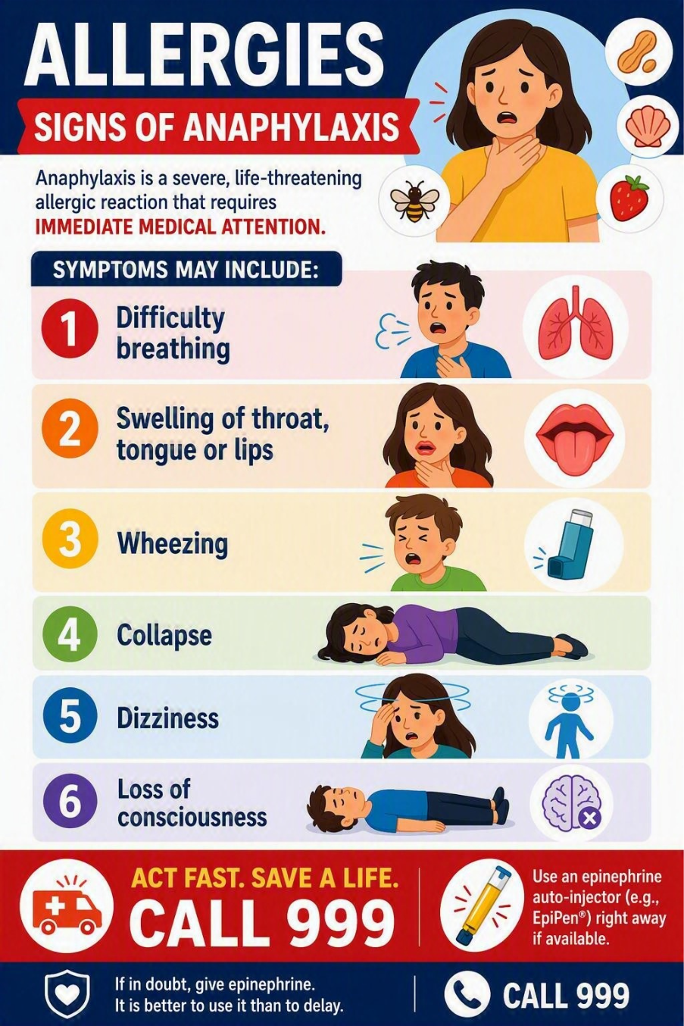

Emergency Procedure flowchart (DOH, guidance on AAIs in schools, 2017):
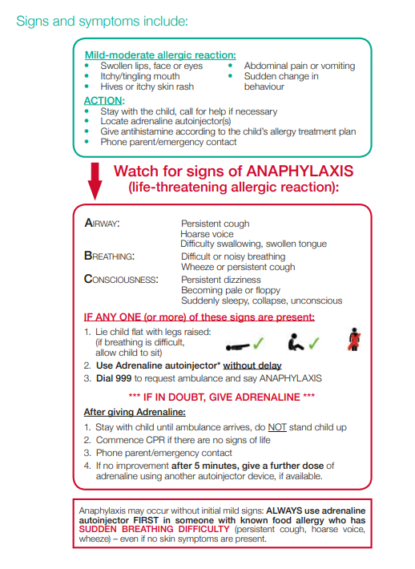

Incident recording
The school will record serious incidents and ‘near misses’ relating to allergy safety as soon as is feasible. The incident will be recorded in the accident book, including the following information:
- Who was affected
- What happened, when and where
- Why the incident occurred (as far as is known)
- How staff and pupils responded and what was done to support the individual
- Whether emergency services were called
- How the incident concluded
The school will approach serious incidents and ‘near misses’ in a ‘no blame’ spirit of seeking to learn lessons.
Incident reporting
The parent(s), carer(s) and family of a student aged up to 16 should be notified of the incident or ‘near miss’ as soon as possible. In the case of a student aged 16 and over, the school will confirm that the pupil agrees that their parents/carers should be informed.
They will be given the opportunity to discuss what happened and to contribute their views to the consequent lessons learned review. The school will then confirm what we have learnt from the incident and outline any actions we are taking as a result.
In some cases, the impact of exposure to an allergen at school may be delayed and not recognised until the student is at home. This means that incident reporting is not limited to staff – the student, parent(s)/carer(s) or family or others (such as healthcare professionals) will need to report to the school if there has been an incident with a delayed reaction.
Staff will always share the incident report with Maddy Irvine. The Allergy Safety Lead will consider whether the allergy safety arrangements in place were appropriate or if changes are needed to this policy and/or the student’s IHP. Any learning will be shared appropriately with staff so they can act on them and reduce the chance of an incident reoccurring.
The school will also share the report with other agencies in the following circumstances:
With the Health and Safety Executive (HSE): incidents which arise directly out of the way the school carried out a work activity which results in death or immediate hospitalisation.

To the local authority: any allergen-related food safety incidents.
https://www.gov.uk/find-your-local-food-safety-team
If the incident or ‘near miss’ was related to the delivery of a care plan or action plan issued by a healthcare professional, the relevant healthcare professional will be notified.

Supporting Pupils with Epilepsy
Epilepsy is a neurological condition affecting thousands of school-aged children in England. Schools must recognise that epilepsy can affect learning, concentration, memory, attendance, wellbeing and participation.
An epileptic seizure happens when there is a sudden electrical discharge in the brain. It can happen in different parts of the brain. The type of seizure depends on where in the brain the sudden electrical discharge happened.
For more information, follow the link:
https://www.youngepilepsy.org.uk/about-epilepsy/epileptic-seizures/seizure-types

School Responsibilities
The school will:
- Maintain an Individual Healthcare Plan.
- Ensure staff understand the pupil's seizure type(s).
- Ensure appropriate training is provided.
- Support participation in educational visits and physical education.
- Make reasonable adjustments where required.

Monitor any impact on attendance, wellbeing, and achievement.

Epileptic Seizures

Tonic-Clonic (Convulsive) Seizures
A tonic-clonic seizure may involve loss of consciousness, body stiffening, jerking movements, altered breathing and post-seizure confusion.

Step 1: Stay Calm and Ensure Safety
- Always remain with the student.
- Send another member to obtain assistance if required.
- Reassure nearby students and maintain privacy where possible.
- Note the time the seizure starts.

Step 2: Protect from Injury
- Remove nearby furniture, equipment, or hazards.
- If possible, place something soft under the student's head (coat, jumper, or cushion).
- Move other pupils away from the immediate area.
- Allow the seizure to run its course naturally.

Step 3: Do Not Restrict Movement
Staff must never:
- Hold the student down.
- Attempt to stop the jerking movements.
- Restrain limbs.
- Move the student unless there is immediate danger (e.g. traffic, fire, machinery).

Step 4: Do Not Put Anything in the Mouth
Staff must never:
- Place objects between teeth.
- Attempt to force the mouth open.
- Give food, drink, or medication during the seizure.

Step 5: Monitor and Time the Seizure
Record:
- Time seizure began.
- Type of movements observed.
- Any changes in breathing.
- Any injury sustained.
- Length of seizure.
Accurate timings are particularly important for healthcare professionals and may determine when emergency servicesPolicy,ontacted.

Step 6: As the Seizure Ends
Once the jerking movements stop:
- Check breathing.
- Check for injuries.
- Gently place the student in the recovery position if appropriate.
- Loosen tight clothing around the neck.
- Continue monitoring closely.

Step 7: Recovery Period
Following a seizure, students may:
- Be confused.
- Feel tired.
- Experience headaches.
- Need sleep or rest.
- Be embarrassed or distressed.
Staff should:
- Speak calmly and reassuringly.
- Explain what has happened.
- Allow time to recover.
- Maintain dignity and privacy.
- Remain with the student until fully recovered or until emergency services arrive.

Summary of emergency response:
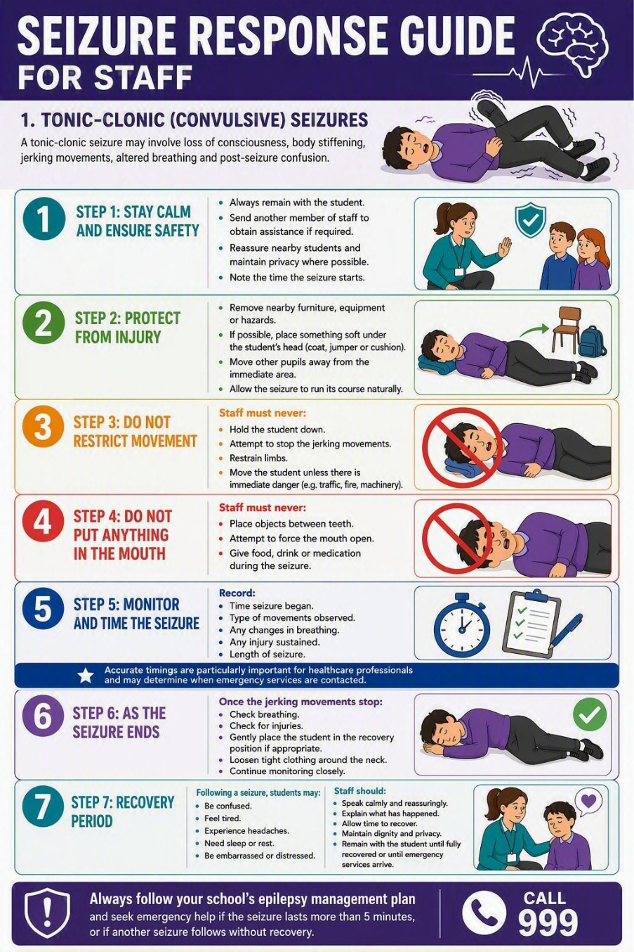

The Recovery Position

- Remove hazards – this may include sharp objects in pockets
- Turn the student carefully onto their side.
- Tilt the head slightly back to keep the airway open.
- Bend the upper leg for stability.
Continue monitoring breathing until recovery or emergency services arrive.

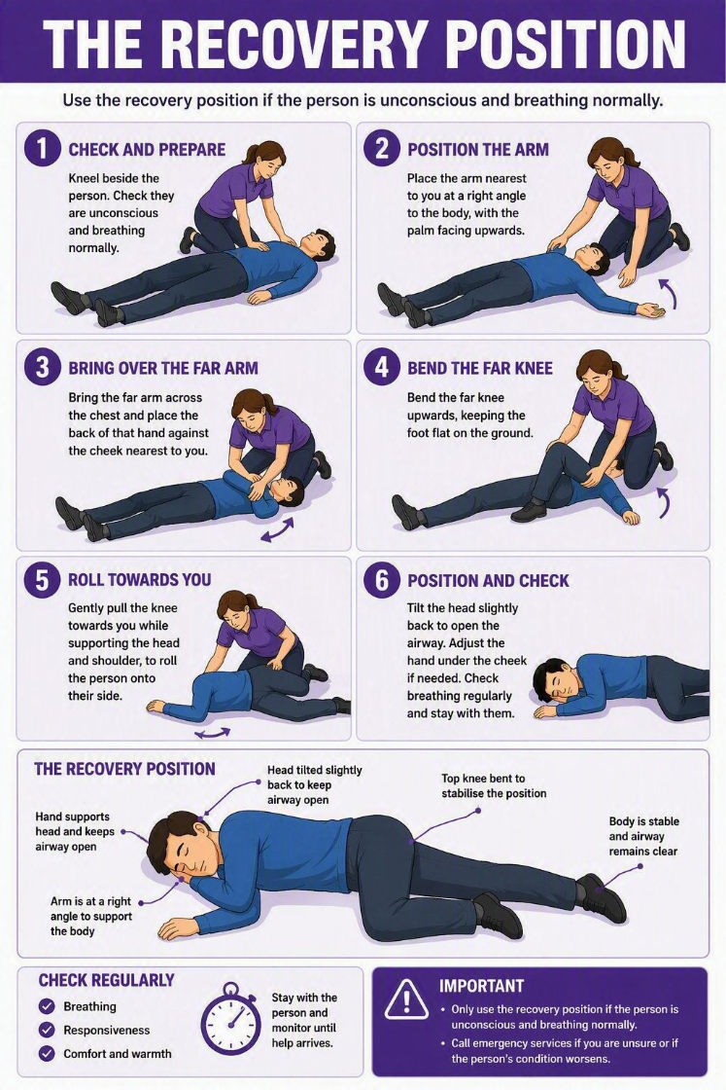

When to Call 999
An ambulance must be callequipment,ately if:
- It is the student's first known seizure.
- The seizure lasts longer than specified within their Individual Healthcare Plan.
- A seizure lasts five minutes or more where no personalised advice exists.
- One seizure follows another without recovery.
- The student sustains a significant injury.
- Breathing difficulties occur.
- The student remains unconscious.
- Rescue medication has been administered, and emergency assistance is required.
- Staff have any concerns regarding the student's condition.

REMEMBER:
🛡️ PROTECT
👀 OBSERVE
💬 REASSURE
📝 RECORD

Administration of Rescue Medication
Some students may be prescribed emergency rescue medication, such as Buccal Midazolam.
Buccal – means the space between the gum and cheek where the medicine is administered.
Midazolam – is the name of the medicine. It works by reducing electrical activity in the brain which can stop seizures.
- Only trained and authorised can administer this medication.
The school has:
- Enough staff members trained to give the rescue medicine
- There are enough staff also trained to do so in case of absences
The school securely stores emergency medicine in a secure place in reception that is easily accessible in an emergency.
Staff must:
- Follow the Individual Healthcare Plan exactly.
- Check the correct pupil, medication and dose.
- Record the time medication is administered.
- Monitor the pupil continuously afterwards.
- Follow instructions regarding when to call emergency services.

A minimum of two trained staff should be available wherever reasonably practicable.

Non-Convulsive Seizures
Not all seizures involve collapsing or shaking.

Absence Seizures
Signs may include:
- Brief periods of staring.
- Lack of awareness.
- Momentary interruption of activity.
- Immediate return to normal activity.
Staff should:
- Stay with the student.
- Gently repeat instructions afterwards if needed.
- Record repeated episodes.
- Report concerns to parent(s), carer(s) and family and inform Tracey Richards.

(ii) Focal Seizures
Signs may include:
- Confusion.
- Wandering.
- Repetitive movements.
- Unusual sensations.
- Altered awareness.
Staff should:
- Remain calm.
- Guide the student away from danger.
- Offer reassurance.
- Stay with them until awareness fully returns.

Post-Seizure Recording
Following every seizure, staff should complete a Medical Incident Record, found in each reception, including:
- Date and time.
- Duration of seizure.
- Type of seizure observed.
- Any trigger factors identified.
- Injuries sustained.
- Medication administered.
- Whether emergency services attended.
- Staff involved.
- Parent(s)/carer(s)/family communication.
A review of the Individual Healthcare Plan should be undertaken following any significant seizure event or change in presentation.
Asthma
Asthma is a common condition that affects breathing. It cannot currently be cured, but if it is well treated you should not have problems with symptoms.
The signs of an asthma attack are:
- Persistent cough (when at rest)
- A wheezing sound coming from the chest (when at rest)
- Difficulty breathing (the child could be breathing fast and with effort)
- Nasal flaring
- Inability to talk or complete sentences. Some children will go very quiet.
- Chest ‘feels tight’ (younger children may express this as tummy ache)

Emergency procedure
Call 999 for ambulance immediately and commence the ‘asthma attach’ procedure without any delay if the student:
- Appears exhausted
- Has a blue/white tinge around lips
- Is going blue
- Has collapsed

Asthma Procedure:
- Stay as calm as possible
- Use the student’s own inhaler – if not available, use the emergency inhaler
- Remain with the student while the inhaler and spacer are brought to them
- Immediately help the student to take two separate puffs of salbutamol via the spacer
- If there is no immediate improvement, continue to give two puffs at a time every two minutes, up to a maximum of 10 puffs
- Stay with the student until they feel better. The student can return to school activities when they feel better
- If the student does not feel better or you are worried at ANYTIME before you have reached 10 puffs, CALL 999 FOR AN AMBULANCE
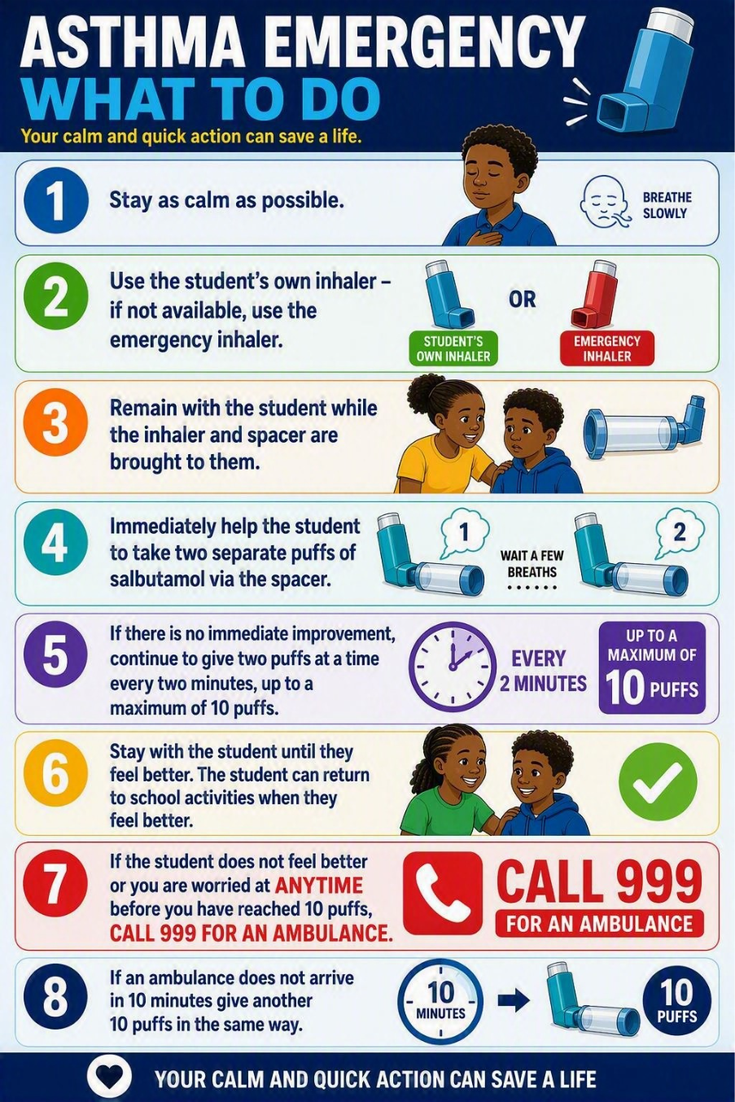
- If an ambulance does not arrive in 10 minutes give another 10 puffs in the same way

An emergency asthma inhaler kit

This kit should include: -
- A salbutamol metered dose inhaler with least two plastic spacers compatible with the inhaler
- Instructions on using the inhaler and spacer
- Instructions on cleaning and storing the inhaler; - manufacturer’s information
- A list of students permitted to use the emergency as detailed in IHP
- Checklist of inhalers, identified by their batch number and expiry date, with monthly checks recorded
- Equipment must be fully washed after use as recommended in statutory guidance.

Website link:
https://www.gov.uk/government/publications/emergency-asthma-inhalers-for-use-in-schools
Nadine Hill will oversee emergency kits at Kingston Maurward and Julia Burgess will do likewise at Poundbury. Tracey Richards has overall responsibility for these kits, including their secure storage in the reception areas and any reordering that will be necessary.
While Salbutamol is a safe medicine, particularly if inhaled, but all medicines can have some adverse effects. Those of inhaled salbutamol are well known, tend to be mild and temporary and are not likely to cause serious harm. The student may feel a bit shaky or may tremble, or they may say that they feel their heart is beating faster.
The main risk of holding salbutamol inhaler for emergency use is that it may be administered inappropriately to a breathless child who does not have asthma. It is essential therefore that school staff ensure that the inhaler is only used by children who have asthma or who have been prescribed a reliever inhaler, and for whom written parental consent.

Specialism, PE & Off-Site activity
School policies and practices mean that all staff endeavour to be as inclusive as possible to ensure that all students can fully access the curriculum. Irt is reasonable to expect that all teachers to provide appropriate reasonable adjustments to support students with asthma.
- All teachers should know which children in their class have asthma
- Students have asthma have an IHP on ARBOR
- Students with asthma are encouraged to participate fully in all lessons
- Staff will allow students whose asthma is triggered by exercise to take their reliever inhaler before the lesson, and to thoroughly warm up and down before and after the lesson.
- If a student needs to use their inhaler they will be encouraged to do so.
- Classroom teachers follow the same principles as described above
- All teachers are aware of the potential triggers for students with asthma and what to do in the event of an asthma attack.

Diabetes

- Type 1
Type 1 diabetic students have blood sugar levels that are too high because insulin cannot be made.
In terms of prevalence, fewer than one in 10 people in the UK who have diabetes have type 1 diabetes. There is nothing you can do to prevent yourself or others developing type 1 diabetes. Although it is often diagnosed in childhood, people can develop type 1 diabetes at any age.
Insulin is the main treatment for type 1 diabetes. Diabetics cannot live without insulin injections or using an insulin pump. Checking and managing blood sugar levels is important to help reduce the risk of serious short or long-term health problems. These are called diabetes complications. There is currently no cure for type 1 diabetes.
Generic symptoms of Type 1 diabetes
- Toilet – needing to urinate more often, especially at night.
- Thirsty – being constantly thirsty and not being able to quench it.
- Tired – being incredibly tired and having no energy.
- Thinner – losing weight without trying to or looking thinner than usual.

- Type 2
Type 2 diabetes is when there are high blood sugar levels in the body and it is not making enough insulin, or the insulin it makes not working properly, known as insulin resistance.
High blood sugar levels over time can cause other health problems like heart attacks and strokes, as well as problems with your eyes, kidneys, and feet. These are called diabetes complications.
Treatment includes regular health checks and getting support to be active, eat healthily, and maintain a healthy weight. Type2 diabetics may need to take medication, including insulin. Type 2 diabetes is more prevalent in ethnic minority people and people over the age of forty.

Generic symptoms of Type 2 Diabetes
- Toilet – needing to urinate more often, especially at night.
- Thirsty – being constantly thirsty and not being able to quench it.
- Tired – being incredibly tired and having no energy.
- Thinner – losing weight without trying to or looking thinner than usual.

- Cuts and wounds taking longer to heal.
- Blurred eyesight.
- Behaviour changes like feeling more irritable.

Diabetic Emergencies

Hypoglycaemia (Low Blood Sugar)
Symptoms may include:
- Sweating
- Shaking
- Confusion
- Irritability
- Difficulty concentrating
- Loss of consciousness
Staff will:
- Follow the Individual Healthcare Plan.
- Provide fast-acting glucose if the pupil is conscious and able to swallow.
- Seek immediate medical assistance where required.

Hyperglycaemia (High Blood Sugar)
Symptoms may include:
- Excessive thirst
- Frequent urination
- Tiredness
- Nausea
- Abdominal pain

The Individual Healthcare Plan will provide specific instructions for each student.

Summary of the emergency procedures related to HYPOGLYCAEMIA

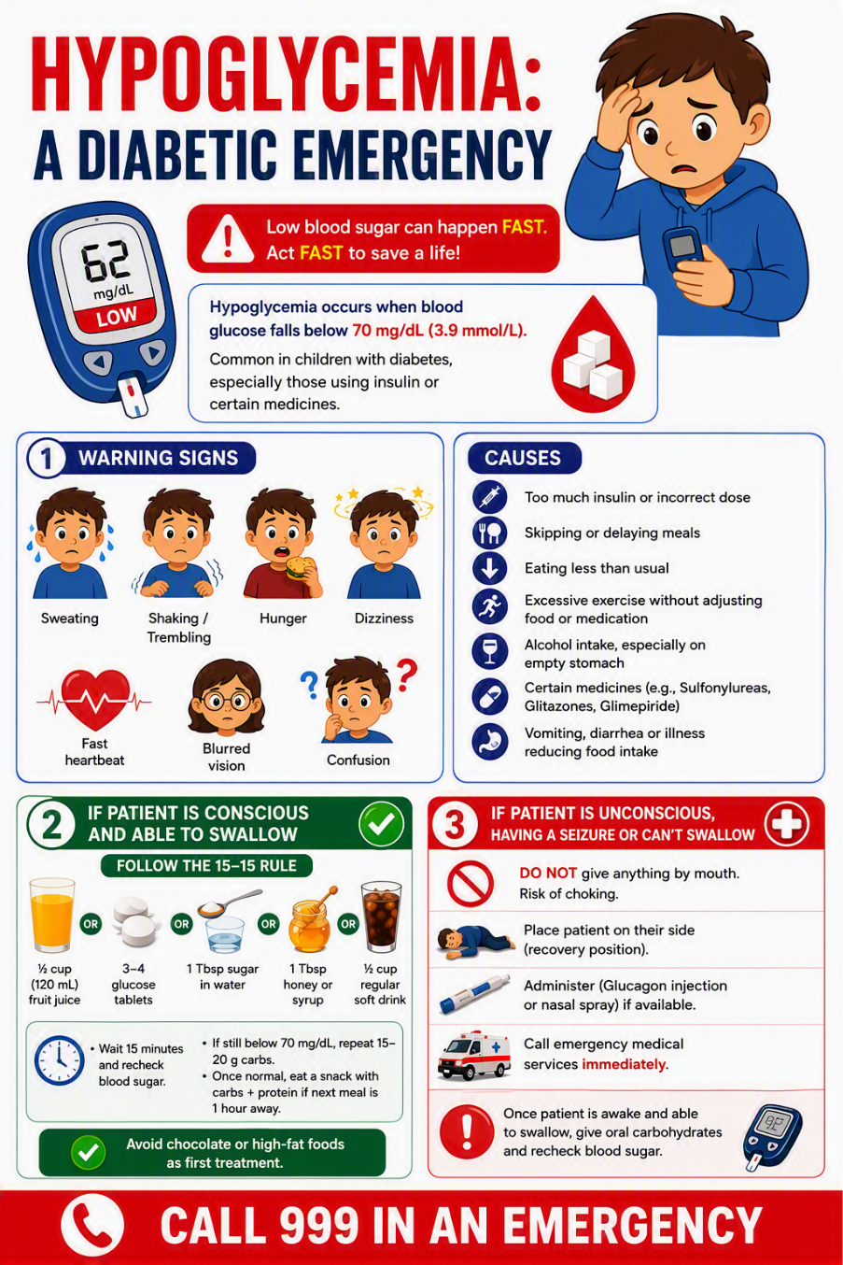

School Visits and Off-Site Activities

Students with medical conditions will be actively included in educational visits.
Prior to visits, staff will:
- Undertake risk assessments.
- Consider medication requirements.
- Ensure trained staff are present where necessary.
- Carry emergency healthcare information.
- Sign out medication
- Sign in medication
- No student will be excluded solely because of a medical condition unless a robust risk assessment demonstrates that participation cannot be made safe.

Emergency Medical Information Card for residential trips
The school will maintain an emergency summary sheet for pupils with high-risk medical conditions containing:
- Photograph (where consent is provided)
- Medical condition
- Known triggers
- Medication required
- Location of medication
- Emergency actions
- Parent/carer contacts
These summary plans will be available to appropriate staff whilst maintaining confidentiality and compliance with UK GDPR requirements.

Unacceptable Practice
- The school will not:
- Prevent a student from accessing medication.
- Assume all students with the same condition require identical support.
- Exclude students from activities without evidence-based risk assessment.
- Send students home frequently because their condition is perceived to be difficult to manage.
- Ignore the views of the student and their parent(s)/carer(s) or family.
- Ignore the advice contained within Individual Healthcare Plans.
- Send students alone for medical triage when there are obvious signs of them being unwell

Training
The school will ensure:
- Appropriate medical condition awareness training for staff.
- Condition-specific training where required.
- Regular refresher training.
- Allergy awareness training consistent with current statutory expectations.
Training records will be maintained by the DSL and/or operational DSL. These will be available for review by senior leaders and governors.

Complaints
Concerns regarding support for students with medical conditions should initially be raised with the SENDCO, Katherine Young.
Where concerns remain unresolved, parents may use:
- The school's complaints procedure.
- Relevant statutory routes of appeal.

In the first instance, any complaint related to the school’s policies and procedures related to students with medical conditions should be sent to Tracey Richards.

tracey.richards@dorsetstudioschool.co.uk

If the complaint cannot be resolved at this informal stage, then parent(s)/carer(s) and family should follow the school’s complaints policy which is available on the school’s website.

Monitoring and Review
This policy will be reviewed annually or sooner if:
- Legislation changes.
- DfE guidance is updated.
- Following a significant medical incident.
- Following recommendations from health professionals or the Governing Body.

Appendix 1: IHP for a student with an allergy

NAME – Individual Healthcare Plan for allergy
Date of birth: | Current photo
Year / class: | Current photo
Emergency contacts: | Current photo
Staff who need to be aware: | Current photo
Allergy:
Note what allergy the child or young person has.
Note any known allergens.
Note whether the child or young person is likely to be aware that they are having an allergic reaction and whether they can alert others.
How the allergy is managed:
Note any care or action plans or prescribed medication issued by healthcare professionals.
If the allergy can be partly or wholly managed by practical adjustments (for example avoidance of known allergens), note them here.
Note the extent to which the child or young person is able to take responsibility for managing their allergy.
Impact on education:
Indicate the potential harm which might come to the child or young person if their allergy is not managed properly.
Indicate how the allergy may impact on the child or young person’s learning.
Indicate how the allergy may impact on the child or young person’s emotional wellbeing.
If relevant, note any interaction between allergy and SEN.
Arrangements for support:
Give details of the specific support or adaptations which the school, college or early years setting will put in place, within its educational remit.
Outline measures to reduce the risk of contact with known allergens.
Give details of the specific support or adaptations to manage food allergy at meal and snack times.
Note arrangements for maintaining educational progress where absence or missed learning occurs due to allergy.
Visits and trips:
- Give details of any arrangements or procedures which may be required for school trips or other activities outside of the normal timetable that will ensure the child can participate.
- Note any requirement for a risk assessment and prompts for specific issues which should be considered.
Emergency response:
Where an Action Plan issued by a healthcare professional covers emergency response, refer to it and ensure it is attached.
Otherwise summarise the signs or symptoms which would indicate an emergency.
Set out what to do in an emergency, including whom to contact.
If relevant, note where “spare” adrenaline devices are located.
Parents/carers/family are responsible for ensuring that the school is aware of their child’s needs and should update the school as necessary
Last discussed with parents: | Date
Issued by: | Date:
Next planned review: | Date:

Appendix 2: IHP for students with epilepsy

NAME – Individual Healthcare Plan for EPILEPSY
Date of birth: | Current photo
Year / class: | Current photo
Emergency contacts: | Current photo
Staff who need to be aware: | Current photo
Epilepsy
Specific details of the epilepsy.
How the Epilepsy is managed:

Seizure triggers (if known):
Note any care or action plans or prescribed medication issued by healthcare professionals.

Impact on education:
Indicate the potential harm which might come to the child or young person if their epilepsy is not managed properly.
Indicate how the epilepsy may impact on the child or young person’s learning.
Indicate how the epilepsy may impact on the child or young person’s emotional wellbeing.

Emergency Response
Name and dose of medicine:
Named individual(s) who may give medicine
Emergency response:

Set out what to do in an emergency, including whom to contact.
If relevant, note where “spare” medication is located.
Time when medication was administered
Arrangements for off-site activities, incl. School trips

Arrangement for residential trips:

Parents/carers/family are responsible for ensuring that the school is aware of their child’s needs and should update the school as necessary
Last discussed with parents/carers/family: | Date
Discussion with healthcare professional | Date:
Issued by: | Date:
Next planned review: | Date:

Appendix 3 – An IHP for a student with asthma

NAME – Individual Healthcare Plan for ASTHMA
Date of birth: | Current photo
Year / class: | Current photo
Emergency contacts: | Current photo
Staff who need to be aware: | Current photo
NAME & STRENGTH OF THE INHALER
Specific details of the inhaler should be added.
How ASTHMA is managed:

How the inhaler is used
What to do once the inhaler has been used
What to do if the inhaler does not initially work

Impact on education:
Indicate the potential harm which might come to the child or young person if their asthma is not managed properly.
Indicate how the as may impact on the child or young person’s learning.
Indicate how the epilepsy may impact on the child or young person’s emotional wellbeing.

Emergency Response
Emergency response:

Set out what to do in an emergency, including whom to contact.
If relevant, note where “spare” medication is located.
Time when medication was administered

USE OF EMERGENCY SALBUTAMOL INHALER
I can confirm that my child has been diagnosed with asthma & has been prescribed an inhaler [
My child has a working, in-date inhaler, clearly labelled with their name, which will be kept in school for their use
In the event of my child displaying symptoms of asthma, and if their inhaler is not available or is unusable, I consent for my child to receive salbutamol from an emergency inhaler held by the school for such emergencies.

Arrangements for off-site activities, incl. School trips

Arrangement for residential trips:

Parents/carers/family are responsible for ensuring that the school is aware of their child’s needs and should update the school as necessary.

Last discussed with parents/carers/family: | Date
Discussion with healthcare professional | Date:
Issued by: | Date:
Next planned review: | Date:

