
GCSE History (9-1): Overview
Paper 1:
Medicine In Britain c1250-Present
- Unit 1: c1250-c1500 Medicine in medieval England
- Unit 2: c1500-c1700 Medieval Renaissance in England
- Unit 3: c1700-c1900 Medicine in the 18th & 19th Centuries
- Unit 4: c1900-present Medicine in modern Britain
- Unit 5: The British sector of the Western Front c1914-18
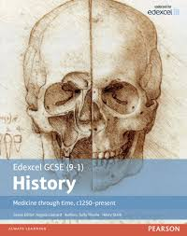

Paper 2:
Anglo-Saxon & Norman England c1060-c1088
- Unit 1: Anglo-Saxon England & Norman Conquest c1060-c1088
- Unit 2: William I in Power, securing the kingdom c1066-c1087
- Unit 3: Norman England c1066-c1088

Superpower Relations & the Cold War c1941-c1991
- Unit 1: Origins of the Cold War c1941-c1958
- Unit 2: The development of the Cold War c1958-c1970
- Unit 3: The end of the Cold War c1970-c1991
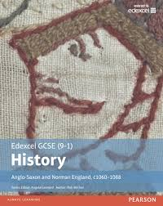

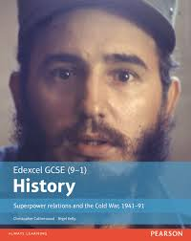

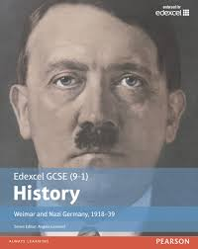
Paper 3:
Weimar & Nazi Germany c1918-c1939
- Unit 1: The Weimar Republic c1918-c1929
- Unit 2: Hitler’s rise to power c1919-c1933
- Unit 3: Nazi control and dictatorship c1933-c1939


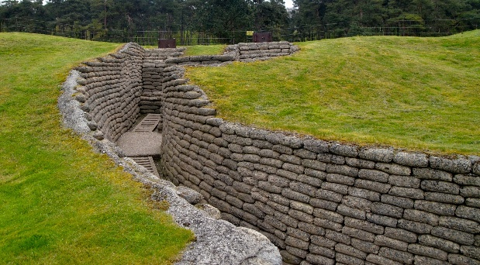
Pearson Edexcel GCSE History cover a range of global topics from the past as well as British History. Each module is designed to focus on studies in ‘depth’ or ‘breadth’ and offer exciting learning opportunities outside of the classroom including visits to the World War I battlefields of France & Belgium (below left) and Berlin (below right).


GCSE Geography (9-1): Overview
Paper 1 (1hr 30 mins): Living with the physical environment
- Section A: The challenge of natural hazards (tectonic & weather hazards plus climate change)
- Section B: The Living World (ecosystems; tropical rainforests & hot deserts)
- Section C: Physical landscapes in UK (rivers & coasts)

Paper 2 (1hr 30 mins): Challenges in the human environment
- Section A: Urban issues & challenges (urban world, urban change in UK & sustainable urban development)
- Section B: The changing economic world (development gap, Nigeria case study & changing UK economy)
- Section C: The challenge of resource management (resource management in UK & food management globally)

Paper 3 (1hr 15 mins): Geographical applications & skills
- Section A: Issue evaluation
- Section B: Fieldwork & geographical skills


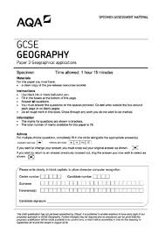

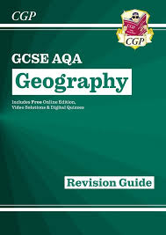
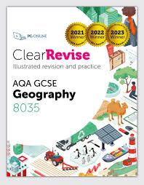
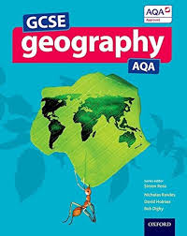
AQA GCSE Geography is divided into three parts with paper 1 focusing on physical geography, paper 2 looking at human geography and paper 3 comprising of skills, an issue enquiry and fieldwork.
The fieldwork element is split into two separate components with students being given the opportunity to test their fieldwork skills and gather data from two contrasting environments: Dorchester’s Brewery Square (below left) and Lyme Regis (below right).
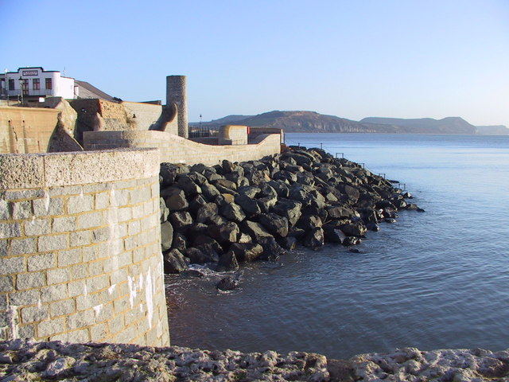
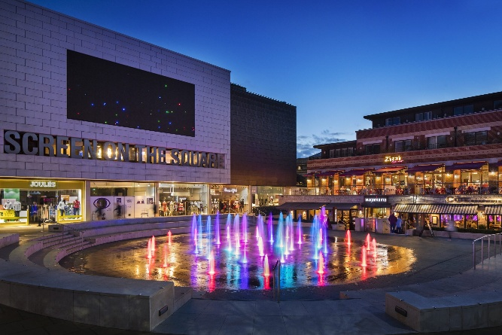

BTEC Hospitality & Tourism: Overview

Unit 1 (Coursework): Exploring Local Visitor Attractions (Year 9 and 10)
- Task A: Research 3 different local visitor attractions for a specific visitor type. You will look at purpose built (e.g. Marwell Zoo), heritage (e.g. Corfe Castle) and natural attractions (e.g. Durdle Door)
- Task B: Create a detailed presentation of one specific visitor attraction identifying; facilities, transport, accessibility etc.

Unit 2 (Coursework): Being Organised (Year 10)
- Task A: Students will learn how to prioritise tasks, time management, use digital tools like calendars and create ‘To Do’ lists. You will be expected to create a personal calendar for a minimum of two weeks.
- Task B: Students will be asked to review the organization methods that the used, looking at the pros and cons of each method.

Unit 5 (Coursework): Using Websites to Make Holiday Choices (Year 11)
- Task A: Conduct research to identify appropriate holiday ideas for a specific visitor type.
- Task B: Create a detailed presentation suggesting a specific location, accommodation, travel options and activities for a specific visitor type.
Unit 4 (Coursework): Developing a Personal Development Program (Year 11)
- Task A: Explore different skills and behaviours, in order to be successful and achieve a particular personal progression goal e.g. be offered a place on a college course or secure an apprenticeship
- Task B: Create a progression plan that includes clear and achievable short and long-term goals.
Unit 3 (Coursework): Exploring Travel & Tourism in UK (Year 10)
- Task A: This topic will focus on different types of UK tourist locations including; countryside areas e.g. Lake District, Seaside Resorts e.g. Blackpool and Historical Cities e.g. Bath. Students will research different locations.
- Task B: Create a detailed itinerary for a week’s holiday is a UK tourist location.

The BTEC Hospitality & Tourism Course focuses on Tourism (3 units) and personal development (2 units) over a two-year period. It is designed to help students develop a range of key skills including: communication, working with others, problem solving, managing information, self-management and development. Each unit of study is assessed by the completion of two pieces of coursework (ten in total). Note, there is no external examination in this qualification.

