

ATTENDANCE POLICY (Revised) 2025-2026
Contents
Introduction and Legal Framework 2
Key Principles 2
Roles and Responsibilities 3
Definitions 4
Promoting good attendance 5
Emotional Based School Avoidance (EBSA) 6
Authorised absence 7
Unauthorised absence 8
Medical Evidence for Illness‑Related Absence 8
SEND and Health‑Related Barriers 8
Persistent and Severe Absence 10
Truancy (Unauthorised Absence Without Permission) 11
Students Absent from Education 11
Legal Interventions 13
Summary of Attendance Codes 15
Absence Requests 16
Staff Training and Evaluation 17
Review of Policy 18

(To be) Approved by: Full Governing Body
Last Review: September 2025 | Next Review: September 2026

Introduction and Legal Framework
This Attendance Policy sets out how the school promotes high attendance, reduces absence, identifies concerns early, and collaborates with parent(s)/carer(s)/families and partners. It aligns with DfE statutory guidance Working Together to Improve School Attendance (effective from 19 August 2024) and the School Attendance (Pupil Registration) (England) Regulations 2024. This guidance confirms attendance expectations are part of the school’s safeguarding responsibilities.

Key Principles
Attendance is everyone’s business: barriers to good attendance can be complex and require whole‑school ownership. With good attendance, students are in a much better position to thrive in school and achieve their full potential. Taking a whole school approach to securing good attendance, recognises its critical importance to inclusion, learning, health and social well-being.
One of the school’s key pillars and priorities is to provide all students with real experiences of work-related learning and industry standard practices. We believe this is the best way of preparing young people with knowledge, skills, and discipline for their economic future. Good attendance in the workplace is a required standard to effectively hold down a job and contribute to the economy. Thus, learning the value of good attendance starts in school.
Good attendance does not necessarily happen by chance. It starts with a clear school culture that sets out the importance of attendance and a graduated response to maximise it.
Dorset Studio School will:
- Promote good attendance and its benefits.
- Ensure that school is safe and supportive of all its stakeholders, including students, so there is a keen sense of belonging.
- Ensure barriers to attendance are overcome as soon as possible through early identification and a support-first approach by working in partnership with parent(s)/carer(s)/families.
- Ensure that multi‑agency collaboration provides holistic, whole‑family support where needed.
- Collaborate with the local authority to seek the use of legal intervention to enforce attendance at school if required to do so.
- Accurately record attendance & absence using statutory codes so that robust monitoring and intervention to prevent absence can follow swiftly.

Roles and Responsibilities

i) The Governing Body
The Governing Body has overall responsibility for the implementation and monitoring of this policy. Within this remit, they must:
- Ensure that school is promoting the importance of good attendance and does not discriminate against any individual or group of individuals based on their protected characteristics.
- Ensure that the school has regard to ‘Keeping Children Safe In Education’ by making arrangements to safeguard and promote the welfare of children. This would also include that the school has a robust Children Absent From Education incl. Children Missing from Education policy in place and enact it.
- Collaborate with senior leaders to ensure that attendance data is regularly reviewed, consider the impact(s) of intervention(s), staff have adequate training on attendance.
- Ensure there is a complaints policy and procedure in place.

ii) The Principal
The Principal is responsible for the implementation and management of this policy by ensuring that relevant processes and procedures are in place to maximise attendance for all students. They will delegate the daily implementation of these to a member of the senior leader team who will function as the school’s Attendance Champion. During the current academic year, this is Mr. Paul Chapman.

iii) Attendance Champion
The Principal will support the Attendance Champion by ensuring they have sufficient resources to maximise attendance for all students within financial capacity constraints.
The Attendance Champion is expected to ensure that all stakeholders know about the school’s attendance expectations and lead the attendance team to support these. The Attendance Champion will be held accountable for attendance procedures and processes to ensure that every effort is made to maximise the attendance for every student.
The Attendance Champion will determine which member of the Attendance Team will lead on enforcing statutory school attendance in partnership with the local authority. The issues of capacity and the knowledge of the student may mean it is in the best interests of the child for another professional within this team to take the lead.

iii) Staff
Staff are responsible for modelling the school’s culture and ethos by ensuring that they are interested and curious about the well-being of all students. If they have concerns about any student, they must follow the school’s safeguarding policy to determine if any concern should be escalated.
As an Academic Coach, they should hold a short purposeful conversation with their allocated students on a regular basis according to the school’s meeting cycle. In this conversation, the importance of good attendance should be discussed, and any patterns of absence should be addressed, and escalated, in writing, to the Attendance Champion if required.

Parent(s)/Carer(s)/Families
Parent(s)/Carer(s)/families have a legal responsibility to ensure that their child/children attend school regularly. To facilitate this, parent(s)/carer(s)/families must:
- Provide accurate, complete, and up-to-date contact details.
- Provide more than one emergency contact number.
- Update school if any changes occur.
- Notify the school of any absence as soon as possible.
- Book medical appointments, including dental ones, around the school day whenever possible.
- Request leave of absence only in exceptional circumstances.
- Adhere to any family-based support implemented by school or other agencies to improve attendance.

Definitions
Attendance expectations will be communicated with parent(s)/carer(s)/families on a regular basis. This will occur at least on a termly basis. In most circumstances, we expect students to attend daily and arrive on time.
A student will be recorded as absent if they are not in the classroom at the point at which the register is taken.
The morning register will be marked at 0900 If the student arrives after this time, they will be marked as late. The morning register will close at 0910. If the student arrives after this time, they will be marked as absent. Students involved in school-related activities that are not conducted in the classroom where the register is taken will be marked in by those staff leading those interventions.
The morning register will be marked at 1215 If the student arrives after this time, they will be marked as late. The morning register will close at 1225. If the student arrives after this time, they will be marked as absent. Students involved in school-related activities not conducted in the classroom where the register is taken will be marked in by those staff leading those interventions.
In general, the school does not expect students to be late for registrations throughout the school day. However, we are aware of mitigating factors such as delays in transport and this is taken into account when it happens. During the school day, lateness to lessons is invariably a matter of poor choice and is dealt with according to the school’s Behaviour & Rewards Policy.

Promoting good attendance
The school routinely promotes good attendance because of the importance that every day counts in school. This is shown in the following infographic:
97% Very Good
95% Good
90% Minimum Standard
85% Persistent Absence
80% Significant Concern
100% Excellent
50% Severe Absence

No days missed
6 days missed
No lessons missed
19 days missed
10 days missed
29 days missed
39 days missed
97 days missed
36 lessons missed
60 lessons missed
114 lessons missed
174 lessons missed
234 lessons missed
582 lessons missed

All staff discuss the importance of good attendance with students through the lens of subject progression. They welcome all students to their classrooms to instill a deep sense of belonging so that students feel safe and respected. They also understand that students who have missed school for whatever reason may be anxious about returning.
Staff may feel temporary, informal reasonable adjustments should be made to quickly integrate the student into class and learning by:
- ‘Buddying up’ with an appropriate peer.
- Relax the seating plan on a limited basis.
- Signpost students to online classrooms where missing work may be found.
- Have a pragmatic approach to the completion of homework by offering additional support or time to complete it.
Academic coaching allows all students to have an individual voice, and this may be used to discuss any barriers to attendance as well as exploring solution-focused steps to overcome them.
Pastoral staff promote the importance of good attendance at every opportunity. These include:
- Regular ‘Shout Out’ conferences, students are publicly recognised for good and improved attendance.
- A half-term attendance afternoon’ reward where students are off timetable to enjoy an enrichment or social activity.
- Celebratory Conferences - attendance prizes are awarded to a student from each year group. The reason for awarding the prize is to provide perspective and inspiration to other students.

Emotional Based School Avoidance (EBSA)
The Attendance Team also runs individual sessions related to those students with acute barriers to attendance. Emotional Based School Avoidance (EBSA) is the ‘catch all’ phrase which broadly describes those students absent from school because of anxiety, or other emotional or physical distress.
Strategies to support the best possible attendance for those students with emotional based school avoidance are covered in greater depth in our Children Absent from Education, incl. Those Children Missing from Education Policy.

The Attendance Champion has oversight and the daily operational lead on all attendance matters. Much of this work is delegated to the Attendance Team, who have clearly defined roles and responsibilities. To achieve good attendance, the school believes that nothing should be left to chance. The following flowchart shows the graduated approach to routine attendance matters:

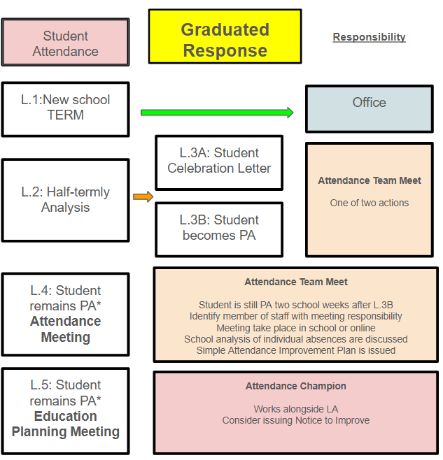

Authorised absence
An authorised absence is either approved by the Principal or accepted as legitimate reason for absence after it occurs. Examples, although not exhaustive, include:
- Illness (that the school will authorise)
- Medical/dental appointments that cannot be arranged outside school hours.
- Exceptional circumstances (e.g., bereavement, funeral, housing crisis, immediate family wedding with evidence), religious observance, cultural observance, and transport failure.

Unauthorised absence
The school does not approve of an unauthorised absence. More obvious reasons for unauthorised absence include:
- Illness where a student has missed five consecutive days of absence and/or school has a genuine and reasonable reason doubt.
- Term‑time holidays
- Cheaper travel
- Holidays booked by relatives
- Absence without explanation
- Late arrival after registers close).

Medical Evidence for Illness‑Related Absence
The school will not routinely request medical evidence; a parent/carer’s explanation is normally sufficient. Evidence may be requested only where there is genuine and reasonable doubt.
The school will consider a variety of documentation as evidence of a student’s absence. These include:
- Dated prescriptions.
- Appointment cards/text images or emails
- A letter from the GP that explicitly makes reference to absence.
- A conversation with parent(s)/carer(s)/families based on the context for the reason(s) for absence.
When evidence is requested for an illness related absence due to reasonable doubt, the school will inform parent(s)/carer(s)/families within 24 hours. To ensure that absences are accurately coded, it is important that the required evidence reaches school as soon as possible. The school will use the following submission windows as a reasonable guide to receive the evidence it requires:
- 1–3 days’ absence—within five school days of the request
- 4+ days or recurrent patterns—within seven school days of the request
- If none is available, discussion with the family may serve as evidence.

SEND and Health‑Related Barriers
Whilst school expects students to attend school daily, it does understand that some barriers to school attendance may be related to the special educational needs of the student. In line with the school’s SEND policy and Supporting Students with Medical Conditions policy, the school will ensure that reasonable adjustments are made to reduce these barriers. However, these adjustments are limited to what the school can efficiently provide and use that is not to the detriment of the effective education of other students. Whenever necessary, the school will consult with external partners and agencies for additional advice and guidance to secure support for good attendance.
Student Mental Health
The school recognises that there may be attendance challenges for those students with social, emotional, and/or mental health conditions, particularly in severe cases where the student is receiving clinical treatment.
It is important to note that students and adults alike will experience difficult emotions that are normal. Students may experience anxiety about peers, friendships, schoolwork, examinations, and variable moods as part of growing into adulthood. In most cases, school expects these students to attend school.
The school will collaborate quickly with parent(s)/carer(s)/families and students, when circumstances arise that may function as a barrier to school attendance. Most anxieties can be mitigated through an individualised plan, containing appropriate and efficient reasonable adjustments.
Parent(s)/carer(s)/families can provide critical help in maintaining attendance at school because they know their children best and are well-placed to recognise and manage their normal emotions.
School asks that parent(s)/carer(s)/families contact school as early as possible when they feel additional support is required. For this support to be effective, it is vital that parent(s) contribute to devising an individualised plan of support. This will require parent(s)/carer(s)/families to meet with those staff leading on setting up the plan, maximising face-to-face meetings as much as possible.
Where support offered is not engaged with, or where other options such as home visits are exhausted or deemed inappropriate, the school will collaborate with the local authority to consider whether more formalised support is required or to enforce attendance through legal intervention in the normal way under their existing powers.
Reasonable Adjustments
Reasonable adjustments are made to ensure that no students are disadvantaged because of their disability. In making any adjustment, the school considers:
- The practicality of the adjustment in the context of the school
- The possible impact on the efficient and effective education of others
- The cost of the adjustment
- Whether there is financial support to maintain it
The following table lists examples of reasonable adjustments that may be suitable for a student depending on their disability, circumstance, and age.
Environmental | Academic | Bespoke
Seating Plan | Knowledge Organiser | Daily ‘Check-In’
Ear Defenders | Assistive Technology | P/T timetable
Focus (fidget) Aid | Additional Adult support | Flexi-Schooling
Overlays | Access Arrangements | School interventions such as ELSA
Pen/Pencil grips |  | Beyond School EBSA intervention
Timer tool |  | External interventions  (taking place in school)
Wobble Cushion |  | Blended Timetable  (containing AP)
Riser table/desk |  | TAF meeting
Use of theraband |  | EH Support
Brain Break
Use of the Support Room
Sheltered Accomodation
The school has an additional policy for those Children with Health Needs that cannot attend school.

Persistent and Severe Absence
The previous infographic shows how damaging Persistent and Severe Absence can be to the education of a student. These students will have significant gaps in their knowledge and skills because of absence. In addition, they may have become isolated from their peers.
- The definition of Persistent Absence
Persistent Absence (PA) is when a student is missing 10% or more of sessions. In a normal school week, this is the equivalent of missing more than one session or the equivalent of half-a-day of school absence.
- The definition of Severe Absence
Severe Absence (SA) is when a student misses 50% or more of sessions. In a normal school week, this is the equivalent of five or more sessions or the equivalent of half-a-week of school absence.

Truancy (Unauthorised Absence Without Permission)
Truancy is defined as absence from school or lessons without school/parent permission, including leaving the site without authorisation or internal truancy. Truancy places students at greater risk of harm because they cannot be effectively safeguarded. In many cases, truancy will be dealt with through the school’s Behavior & Rewards Policy.

Unexplained Absence
If parent(s)/carer(s)/families fail to provide a reason for absence it will be treated as an unauthorised absence and is a safeguarding concern.

Students Absent from Education
The school has robust processes and procedures in place for those Children Absent from Education incl. Children Missing from Education. These are explained in detail in the Children Absent from Education, incl. Children Missing from Education Policy.
Daily attendance monitoring occurs and this means that parent(s)/carer(s)/families will be contacted by a member of the Attendance Team from the first day of absence. The school follows a graduated approach to monitoring and intervention after a ‘Day 1’ absence.

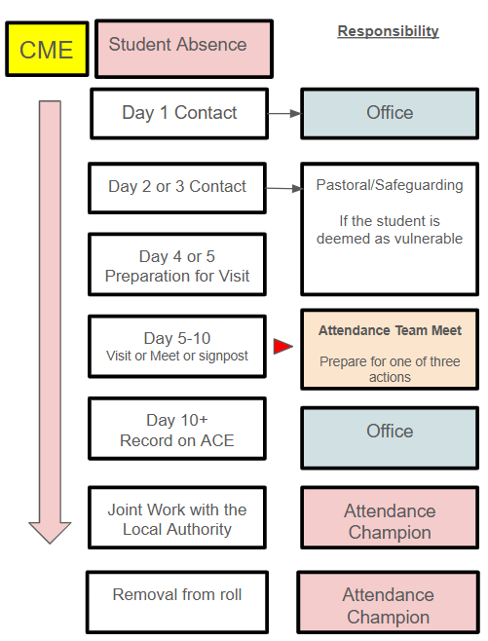

Legal Interventions
The school will allow sufficient time for attendance intervention plans to have a positive impact by improving attendance. If there has been no improvement or insufficient improvement because of a lack of engagement, the school will seek to enforce attendance by legal interventions alongside the local authority. Legal interventions include a range of measures:
(i) Fixed Penalty Notice
A Fixed Penalty Notices (FPN) can be issued at 10 unauthorised sessions within a rolling ten‑school‑week period. This notice starts at £80 if paid within 21 days or £160 within 28 days.
Penalty notices are intended to prevent the need for court action and should only be used where it is deemed likely to change parental/carer/family behaviour. Previous support to secure regular attendance has been provided and has not worked or been engaged with or would not have been appropriate in the circumstances of the offence (e.g., an unauthorised holiday in term time).
There is no right of appeal against a Fixed Penalty Notice. If this is not paid, the local authority can proceed with prosecution or withdraw the notice. The Local Authority can also prosecute parent(s)/carer(s)/family for non-attendance without issuing a Fixed Penalty Notice. Only the local authority can prosecute parents, and they must fund all associated costs. Local authorities must conduct their investigations in line with the PACE Act.
(ii) Parenting Contracts
This is a formal written agreement between parent(s)/carer(s)/families and either school or the local authority to address irregular attendance at school. The contract is not legally binding but allows for a more formal route to secure engagement. This intervention may be used where Early Help has not worked or is deemed to be inappropriate. The use of a contract should be explored before an Education Supervision Order or prosecution.
(iii) Education Supervision Orders
An Education Supervision Order provides court‑ordered local authority attendance supervision without criminal prosecution. In determining whether to progress to an ESO, the school in conjunction with the local authority should have exhausted voluntary support and it would be clear that making the order would be beneficial for the student and parent(s)/carer(s)/family.
For the duration of an ESO, the parent(s)/carer(s)/family has a duty to comply with any directions given under the order. The order initially lasts for one year, but it can be extended for a further period of three years at a time.

(iv) School Attendance Order (SAO)
If the Local Authority is not satisfied that the parent(s)/carer(s)/family are providing a suitable education to a child of compulsory school age and it is appropriate for the child to attend school, they can apply for a School Attendance Order under the Education Act.
The order will require the student’s parent(s)/carer(s)/family to register the child at a named school. Failure to comply with a School Attendance Order amounts to an offence for which the parent can be prosecuted.
If the parent(s)/carer(s)/family do not register the child at a school after the School Attendance Order (SAO) has been issued, the Local Authority may choose to prosecute.
If the court finds that the education provided is not suitable, parents can face a fine of up to £1000.
(v) Attendance Prosecution
Prosecution in a Magistrates Court is the last resort where all other voluntary and formal support has failed. Any Prosecution case must be laid before the court within six months of the alleged offence.
A legal ruling stated that attending school "regularly" means attendance in accordance with the rules prescribed by the school and not "sufficiently frequent attendance". This means that a student must attend school on every day that the school requires them to do so and failure to do this may lead to the commission of an offence. There are two potential offences:

- Section 444(1) Education Act 1996: If the student is absent without authorisation, then the parent(s)/carer(s)/family is/are guilty of an offence. This is a strict liability offence i.e., all that needs to be shown is a lack of regular attendance. Sanctions can include a fine of up to £1,000.

- Section 444(1A) Education Act 1996: an aggravated offence. If the student is absent without authorisation and the parent(s)/carer(s)/family know about the student’s absence and failed to act, then the parent(s)/carer(s)/family is/are guilty of an offence. Sanctions can include a fine of up to £2,500 and a prison sentence of up to 3 months.

Summary of Attendance Codes
The Department of Education uses a standard set of codes for the accurate registration of all students. These codes can be found in the following table:
Code | Meaning
/ | Present in the morning
\ | Present in the afternoon
L | Late Arrival BEFORE registration closes
B | Off-Site Educational Activity
C | Leave of Absence granted by the school for exceptional circumstances
C1 | Leave of Absence for participating in a regulated performance
C2 | Leave of Absence for part-time students
D | Dual Registered
E | Suspended or permanently excluded but no Alternative Provision made
G | Unauthorised holiday
H | Authorised holiday
I | Illness
K | Attending Provision arranged by the Local Authority
M | Medical or dental appointment
N | No reason for absence yet provided
O | Unauthorised absence
P | Approved sporting Activity
R | Religious Observance
S | Study Leave
T | Traveller Absence
Q | Absent due to a lack of Access Arrangements
U | Arrived after Registration closed
V | Educational visit or Trip
W | Attending Work Experience
X | Not required to be in school
Y1 | Absent due to regular transport not being available
Y2 | Absent due to travel disruption
Y3 | Absent due to partial closure of the school premises
Y4 | Absent due to the school site being closed
Y5 | Absent due to Criminal Justice detention
Y6 | Absent due to public health guidance or Law
Y7 | Absent due to any other unavoidable cause
Z | Student not on the Admissions Register
# | Planned whole or partial closure

Absence Requests
The Principal will oversee all requests for absence. The decision to grant or refuse the request will be at their sole discretion. The Principal will make a judgement in the best interests of the student/students and consider the impact of proposed leave on their education. The Principal’s decision is not subject to appeal.
Any circumstance around a request for a leave of absence needs to be an exceptional one. The parent(s)/carer(s)/family should inform the Principal of their request at least two weeks in advance, providing the proposed dates and reason(s) for the absence. These should be made to:
FAO The Principal at info@dorsetstudioschool.co.uk
Requests will always be declined immediately before and during any periods of statutory assessment(s) that the student/students is/are sitting.
If term time absence is declined, taking a student out of school will be recorded as an unauthorised absence and may result in legal intervention such as a Fixed Penalty Notice (FPN).
For any performances and activities, including paid work, the school will require a licence, obtained from the Local Authority. The school expects that in such circumstances, the student will receive at least three hours of education daily. Furthermore, it is the school’s expectation that those providing the tutoring contact the school to follow the relevant parts of curriculum content.

Staff Training and Evaluation

Attendance is everyone’s business. All staff play a key, integral part in ensuring that the school’s culture, ethos, and inclusivity allow all students to thrive in our setting. As a result, all staff receive regular training on attendance and behaviour matters. This training includes:
- Building and maintaining warm & insistent relationships to connect with students
- Early identification of attendance concerns
- Attendance coding procedures
- Safeguarding training
- Arbor training

The impact of the policy is evaluated on an annual basis with monitoring and intervention occurring daily. The impact is measured against a numerical contextual outcome provided by the Department for Education.
For 2025/2026, the school’s indicative Attendance Baseline Improvement Expectation (ABIE) is 87.8%. This target is a minimum expectation and not a ceiling.

85.5%
86.0%
86.5%
87.0%
87.5%
88.0%
88.5 %
89.0 %

Current
ABIE

Review of Policy
This policy will be reviewed annually or sooner if legislation or statutory guidance changes. (Last updated: 1 March 2026).

