**Dorset Studio School**

**Admissions Policy and Arrangements 2024/25**

**Dorset Studio School Contact Details:**

Dorset Studio School, Kingston Maurward, DORCHESTER, Dorset. DT2 8PX

www.dorsetstudioschool.co.uk

01305 443600

Review cycle/date: Annual: January 2024   
 Ratification by February 28th 2024

Party responsible: Full Governing Body

**Introductory Statement**

The school is a mainstream school and centre for educational excellence in animal and land-based learning. All students will complete Level 2 qualifications in Animal Care; Land Based Studies and Travel and Tourism, alongside the core National Curriculum. Students will be educated towards a suite of nine (or ten for students following separate Science qualifications) GCSE and Vocational Qualifications. In line with our professional ethos, all students are expected to maintain the highest standards of attendance, behaviour, attitude and appearance.

Dorset Studio School admits students from across the County of Dorset and beyond in the 11-16 age range.

The Governors will admit a pupil to the School for which the parents have expressed a preference unless to do so would prejudice the provision of efficient education or the efficient use of resources.

*Whilst we have identified a catchment area (appendix 1) ensuring the provision of a local school place for local applicants,* ***historically****,* ***the vast majority of our students have successfully applied from outside of these boundaries****.* ***Our transport routes reach ‘county-wide’ and we both welcome and encourage applications from both within and outside of this defined catchment.***

**Admission Number**

The Published Admission Number (PAN) for year 7 admissions is 75 students. The Studio School’s full capacity is 375 students.

The Governing Body will consult with the local authority (Dorset County) before introducing or changing admission arrangements at least once in each year (September to August).

Our primary purpose is to ensure the provision of a high-quality education for all learners irrespective of gender, ethnicity, social and economic background and circumstances, sexual orientation, physical or intellectual capability, nationality, religion or belief.

**Application Process**

Dorset Studio School is its own ‘admissions authority,’ (The Governors) though participates in the Local Authority co-ordinated scheme for admissions. All deadlines within that scheme should be adhered to by applicants.

Applications for a place at The Dorset Studio School will be made through the Dorset Schools Admissions Team. Further information is available from [admissions@dorsetcc.gov.uk](mailto:admissions@dorsetcc.gov.uk)

If you are applying for a place in Year 7 in September 2024, applications must be made directly to the Dorset County Admissions team by 31/10/23. You will be informed of the outcome on 01/03/24. The late closing date is 28/02/24 and outcomes for this round will be circulated by 30/03/24.

In the event of undersubscription, all applicants will be granted a place.

Where parents/guardians are submitting applications for children of multiple births (ie. twins), the admissions authority will consider the application as a single entity. These applications will continue to be subject to the oversubscription criteria as detailed below. In the example of twins therefore, either both would be admitted or neither.

**Oversubscription Policy**

If the school is oversubscribed, the admissions authority will admit pupils with an Education, Health and Care Plan where the school is named in the Plan.

Where a Local Authority proposes to name the Dorset Studio School in an EHCP made in accordance with section 324 of the Education Act 1996, the Dorset Studio School shall consent to being named, except where admitting the child would be incompatible with the provision of efficient education for other children, and where no reasonable steps may be made to secure compatibility. In the event of any disagreement between the Dorset Studio School and a Local Authority over the proposed naming of the Dorset Studio School in an EHCP, the School may ask the Secretary of State to determine whether the School should be named. The Secretary of State’s determination shall be final.

Applicants with an EHCP naming the Dorset Studio School will be admitted, subject to the exception regarding the provision of efficient education above. In deciding where a child’s inclusion would be incompatible with the efficient education of other children, the School shall have regard to the relevant guidance issued by the Secretary of State to maintained schools.

Priority for admission will then be given to those children who meet the criteria set out below, in the following order:

1. A 'looked after child' or a child who was previously looked after but immediately after being looked after became subject to an adoption, child arrangements, or special guardianship order including those who appear [to the admission authority] to have been in state care outside of England and ceased to be in state care as a result of being adopted. A looked after child is a child who is (a) in the care of a local authority, or (b) being provided with accommodation by a local authority in the exercise of their social services functions (see the definition in Section 22(1) of the Children Act 1989). Where there are more applications than there are places available, the admissions authority will admit students according to the following order of priority:

2. Those students who have a sibling (By sibling we mean: A full brother or sister, stepbrother or sister, adoptive brother or sister and non-blood related children who live with married, single or cohabiting parents in the same household and relates to all year groups provided by the school. We do not include “cousins” within our definition of sibling) who has been admitted in previous years and who will be attending the School at the time of admission.

3. Children of staff with at least two years continuous service at the school or who have been recruited to a vacancy to meet a demonstrable skills shortage as at the date of application (in year) or relevant closing date under the Dorset Council co-ordinated scheme (normal year of entry) and who still intend to be employed at the school at the time of the child’s admission.

4. Students who live within the defined catchment area (see appendix 1). ‘Home Address Proof of Residence’ may be required by the Dorset County Council co-ordinated team. The offer of a place may be withdrawn if proof of residence is not met. Similarly, the offer of a place may be withdrawn if it is found that the address is fraudulent.

5. Remaining places from outside of the catchment area defined in appendix 1, will be allocated on the basis of random selection. Applications will be treated as ‘Lots.’ Lots will be drawn at random by an independent (of the School and Governors) person to determine the final place(s). This process will be conducted, overseen and verified by members of the Dorset Schools Admissions Team.

**Tie break**

In the event that two applicants have equal weighting despite the governing body applying the criteria above, places will be allocated by random allocation, and overseen by a person independent of the school.

**Waiting Lists**

If Dorset Studio School receives more applications than there are places available, a waiting list will be maintained by Dorset Schools Admissions team. Any allocation of subsequent places will be determined in accordance with the oversubscription criteria outlined above.

**In-Year Admissions**

In Year admissions (admissions other than at the normal point of entry) will be maintained by the Local Authority coordinated Scheme. If a place becomes available in the relevant year group then a place will be offered to those applying. In the instance of the school being over-subscribed, then the applications will be considered against the over subscription criteria outlined above, with the opportunity for unsuccessful children to be placed on the waiting list. Anyone refused a place will have the right to appeal to an independent appeal panel.

A school’s published admission number (PAN) applies to the usual point of entry in a school – Reception (primary school), Year 5 (middle school), Year 7 (secondary school) or Year 12 (6th form). For other year groups which are not the usual points of admission, it will be for the admission authority to determine whether there are available spaces or whether admissions beyond a particular level would cause prejudice to the provision of efficient education, i.e. would cause the school practical problems in delivering appropriate educational provision to its existing pupils. It may be the case that admission authorities determine that the PAN (from the point of admission) continues to be a relevant benchmark to determine whether a request for admission can be accepted or rejected, but there may be occasions where the admission authority feels it is necessary to set an operational capacity for a year group or groups which is different to the PAN. It will be necessary for the admission authority to record and evidence those decisions and, where the Local authority is coordinating in-year admissions, provide that decision to the local authority to assist in their operation of that service.

**Fair Access Protocols (FAP)**

When applications are made outside the normal admissions round (and they are not a late application) they are considered in-year applications. Where it can be demonstrated that reasonable measures have been taken to secure a school place through the usual in-year admissions process and this has not been successful, or where a school place has not been sought due to exceptional circumstances, a child may be eligible for referral to the Fair Access Protocol (“FAP”). Dorset Studio School is a signatory to the Dorset County Council Fair Access protocol (FAP). Where relevant, applications will be processed according to the provisions of this protocol.

**Admission Outside Normal Year Groups**

The Principal will make the final decision as to whether a child can be admitted outside of the chronological year group. Relevant applications should be made by contacting the Local Authority admissions team at [admissions@dorsetcc.gov.uk](mailto:admissions@dorsetcc.gov.uk) .The admission will be agreed against the school’s PAN (not in addition) and oversubscription criteria will be applied by the governing body on the same basis as any other applications received.

**Exceptional Circumstances**

The school will only exceed its PAN if, in the governing body's opinion, there is sufficient space to do so without any detrimental effect on the overall quality of the education provided on balance to all students within the school.

**Appeals**

If you or your child is not offered a place at Dorset Studio School you have the right to appeal. In the first instance you must contact the Dorset County Schools Admission team ([admissions@dorsetcc.gov.uk](mailto:admissions@dorsetcc.gov.uk))

**Withdrawal of an offer of a place**

Dorset Studio School may withdraw an offer of a place where a parent fails to respond to an offer within a reasonable timescale or the place was offered on the basis of a fraudulent or misleading application.

**Appendix 1**

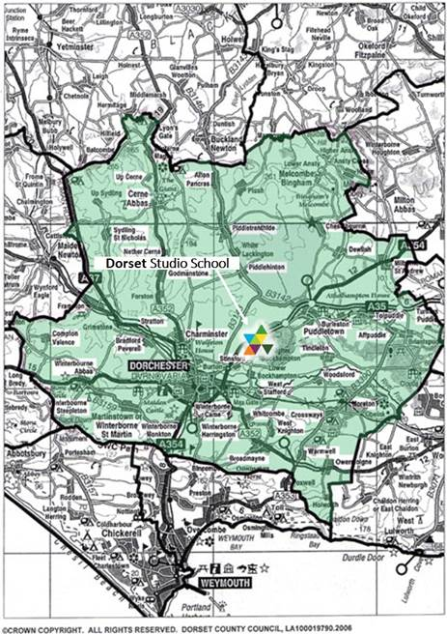Dorset Studio School Catchment Area